[View Static Version](https://spark.adobe.com/page/AA170ErGBBO2W/?page-mode=static)

**Exam Guide: Adobe Certified Expert Magento Commerce Business Practitioner (AD0-E700)**

[](https://spark.adobe.com/page/AA170ErGBBO2W/images/301b64d9-f0be-483d-9c75-9a709ac25f1d.jpg?asset_id=5bbf6ded-6340-41a7-afe0-85a3d0d0fd01&img_etag=%224ae16b1c6359f110fcde705b5664ff1a%22&size=1024)

[](https://spark.adobe.com/page/AA170ErGBBO2W/images/d35b51b8-ad60-4461-8506-0047e4b475cd.png?asset_id=73e42aaa-3c72-4d6f-af5b-05b3dc39d046&img_etag=a8d7c4d408b01751fcfd44b5dd39979c&size=1024)

[](https://spark.adobe.com/page/AA170ErGBBO2W/images/349cd4e2-436c-4925-a9b9-477979ebc94e.png?asset_id=c62c3211-2a2b-48f8-9725-5cb9cee40c25&img_etag=a8d7c4d408b01751fcfd44b5dd39979c&size=1024)

[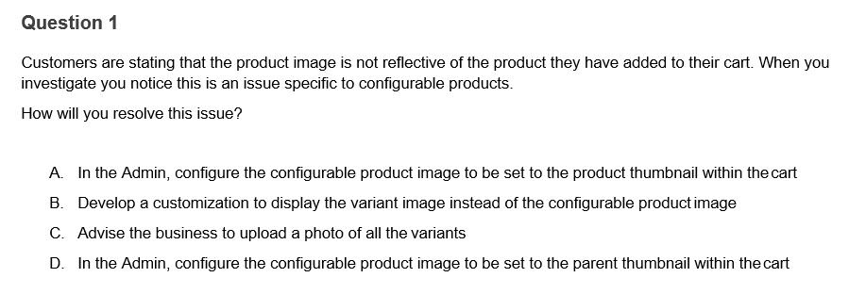](https://spark.adobe.com/page/AA170ErGBBO2W/images/35b14628-fadd-4e6d-9107-09e8f69d1c42.jpg?asset_id=a01cc63c-2b5f-4b21-a08b-7ff272618d3b&img_etag=%2259ecda10f81c85ee742b1efca5668b92%22&size=1024)

[Contact Us](http://certif@adobe.com/)